**PMO Project Notes**

**Access Level**: <https://radacad.com/tag/row-level-security>

**Automatic Update** Data (from SharePoint) in PBI Report: <https://community.powerbi.com/t5/Power-Query/Automatically-update-Power-BI-from-Sharepoint/td-p/633240>

*April 18, ‘23*

**Order/Arrangement**

**-IT Project Details -**

1. ** Project Name (First One)
2. BU
3. Banner
4. Coe
5. Project manager
6. project sponsor
7. Project Health
8. Project Status
9. Phase
10. Size
11. Value Theme
12. Savings
13. System

**April 28, 2023**

**To-do:**

1. BU and Banner **Dimension**
   1. **Python Script**
   2. Web Scrape BU and Banners
   3. **Wag yung galling sa image, i-harvest na lang**
      1. use **name** from list
2. GANTT CHART NEW
   1. May transformation sa:
      1. Fact Table
      2. Milestone Table
      3. **Copy nalang –** Sir Raph
   2. Legend, yung kulay
3. ***Year slicer*** sa Gantt Chart
   1. New from Raph, working as intended (April 27, night)

1. PMO Overview Content *(waiting)*
2. **Row-level security (RLS)**
   1. Learn RLS – nasa **Outlook** yung **Access Level**
3. *Check* ulit yung mga ***Font Sizes***
4. Material Design – implement
   1. Spacing for each Visual Group
   2. Drop Shadow for each VG **or** slight line
   3. Use Z Pattern for importance
   4. Use SVG Background

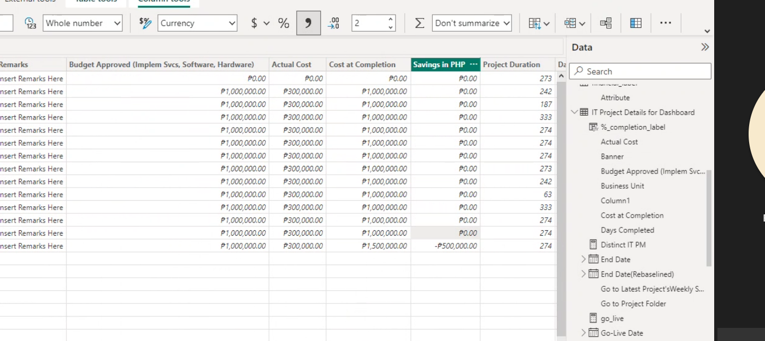

Remove all, except financials, to duplicate everything

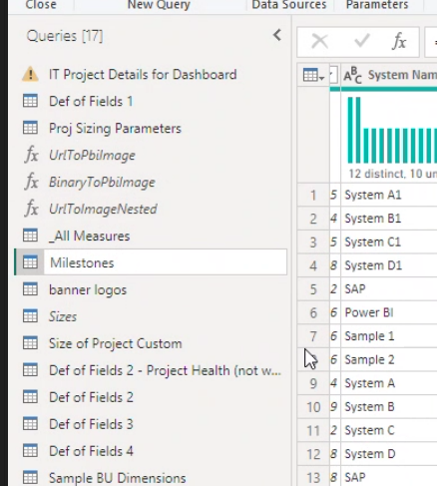

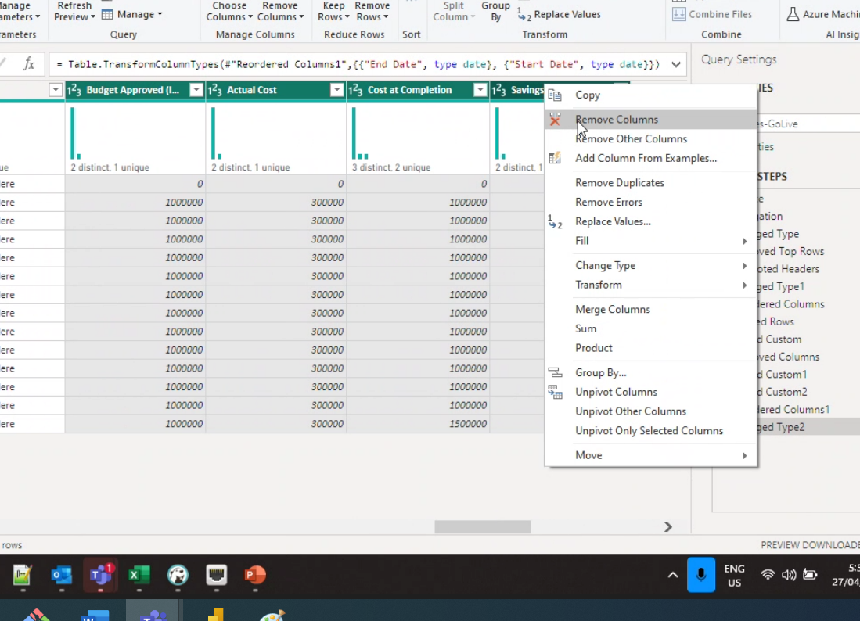

More optimized for performance (vs IF-ELSE):

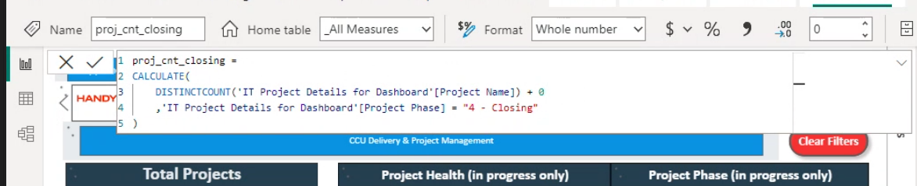

**April 28, 2023**

1. **Row-level security (RLS)**
   1. Learn RLS – nasa **Outlook** yung **Access Level**
   2. Use TUP Email and personal Email to test
2. BU and Banner **Dimension**
   1. Lagay as new model
3. PMO Overview Content *(waiting) + yung additional report*

1. *Check* ulit yung mga ***Font Sizes***
2. Material Design – implement
   1. Spacing for each Visual Group
   2. Drop Shadow for each VG **or** slight line
   3. Use Z Pattern for importance
      * 1. Use SVG Background

Next backlogs: [semi-sorted easy to hard]

1. Contact PMO Form, using with edit perm, **change URL**
2. Wag na liitan yung *first 2 columns* sa *Table*, **remove** nalang
3. Clear filter button, magkaiba ng shape
4. **Project Size**, isama sa page, **nav***’d page*
5. Optimize Performance – instead of using IF-ELSE
6. Box border **all sides**
   1. redesign
7. Additional BU and Banners
   1. Python Script, katamad Manual
   2. Na-download na
      1. Rename
      2. Create an excel File
8. RLS
9. *Gant slicer*: **Matrix Table (see pictures below)**  
     
     
   ----- material design -----
10. Pop up, dropdown [Raph Banner]
    1. Banner BU sa top most
11. Design changes – material Design
    1. **First time user friendly**
       1. UX
12. **Documentation**
    1. Paturo sa mentors how
13. 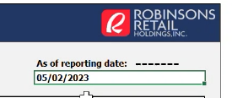**last modified**
14. 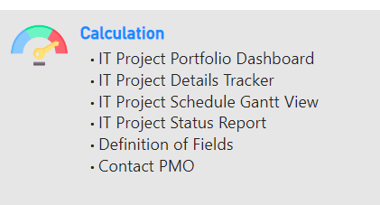 change **Icon**

**RLS NOTES**

TOP G: **C IT** has Access to all:  
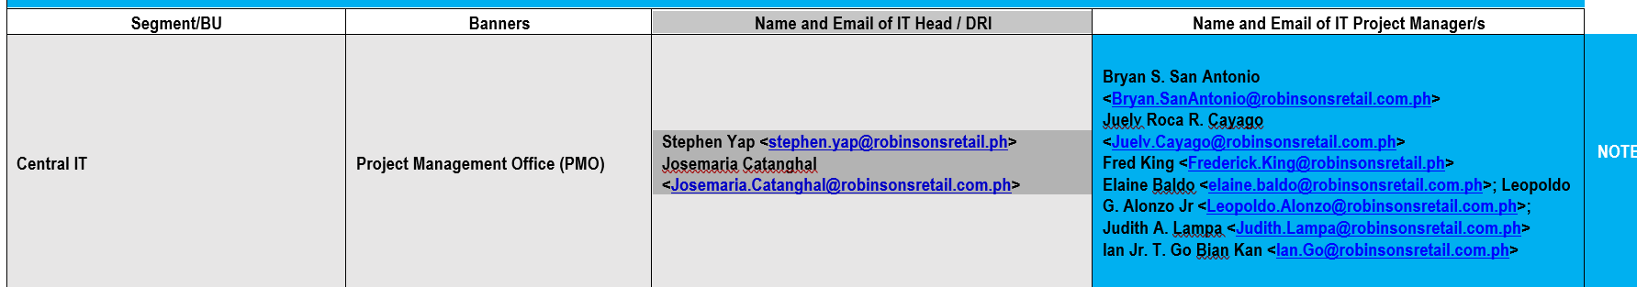

Yung right-most ay sa BU lang nila… (*lowest access*)  
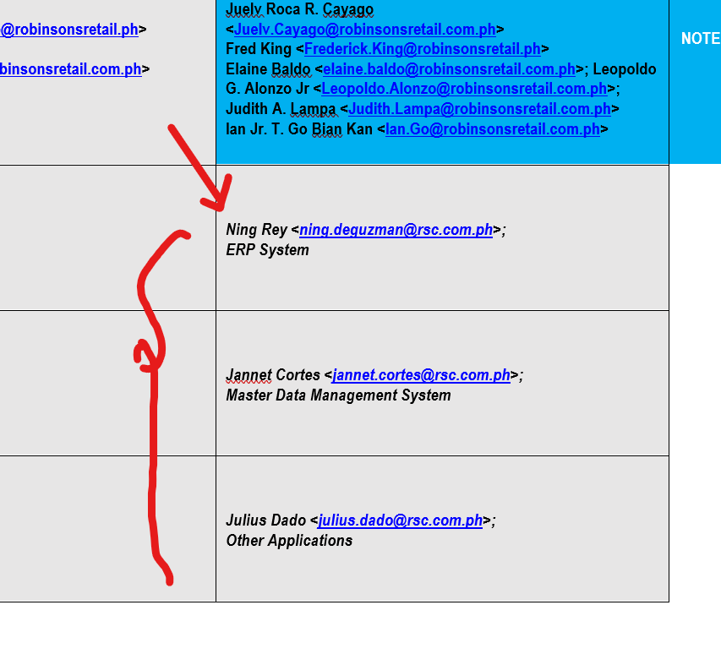

Has Access to all **(buong BU, ex. RSC lang kay Paul Pasia)**

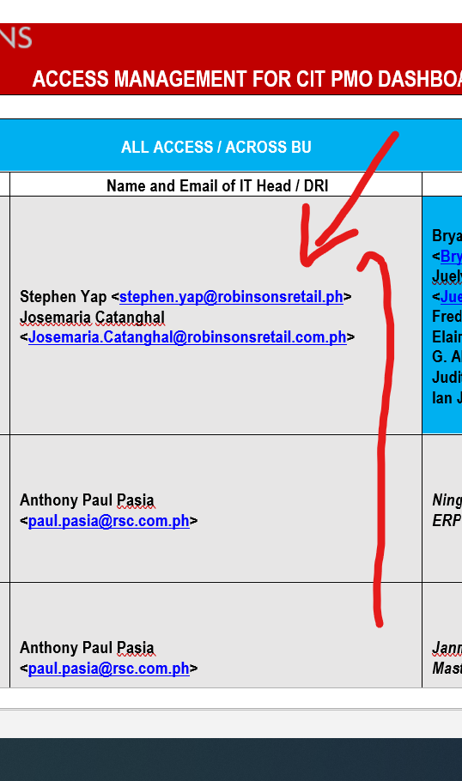

Has Access to Multiple BUs

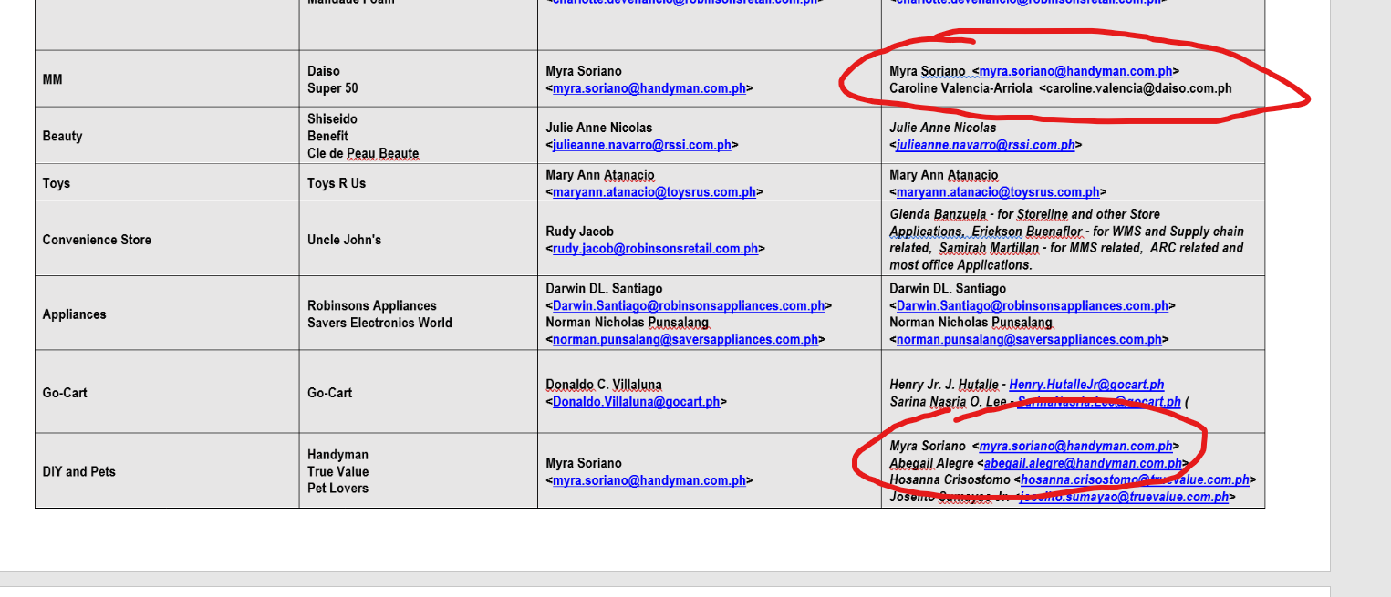

QUESTION:

Yung access ba ay sa BU lang, hindi na kailagan sa Banner level (individual)

Gawa ng ganitong Excel, tapos lagay sa **sharepoint**

Yung image, sa

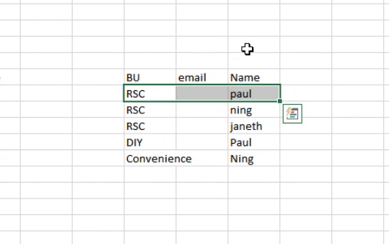

…

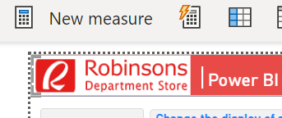

* Consistent Design, Color, Header
* Spacing, margin

Mas manipis na Timeline Slicer

…

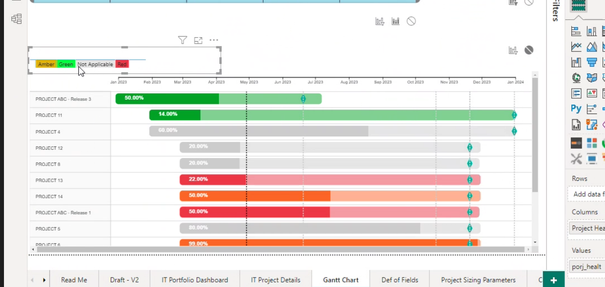

Matrix Table as Slicer::

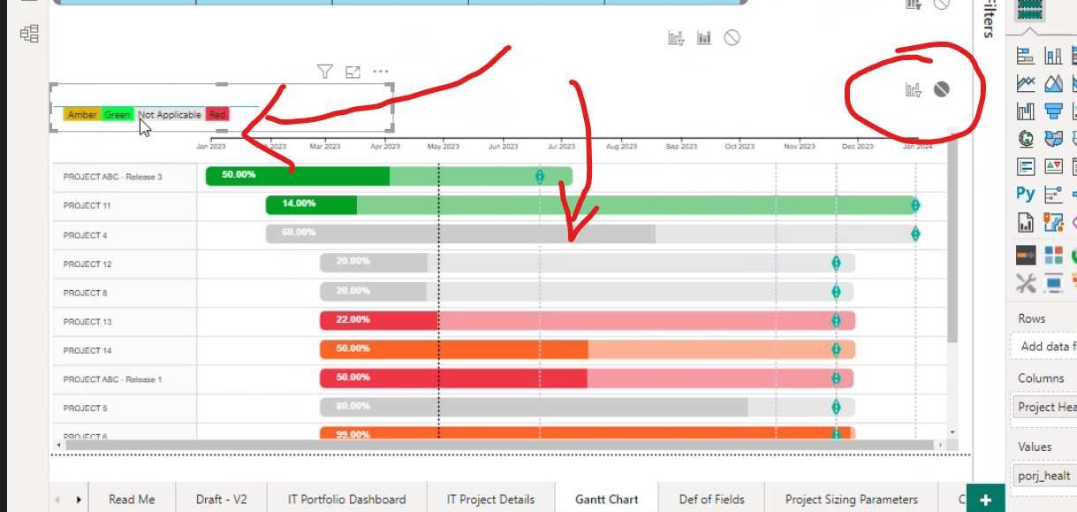

**May 2, 2023**

Notes:

[centralanalyticsintern@robinsonsretail.com.ph](mailto:centralanalyticsintern@robinsonsretail.com.ph)

Next backlogs: [semi-sorted easy to hard]

1. Additional BU and Banners (for Slicers)
   1. Make Relationship from images to BU and Banners && Fact Table
      1. Para gumana yung slicers
2. RLS (*Encoding*)
   1. Harvest from Email (Outlook)
      1. create a Spreadsheet
   2. *Add TUP Email to Demo*
3. **last modified**
4. Optimize Performance – instead of using IF-ELSE  
     
   ----- RE-DESIGN -----
5. Pop up, dropdown [Raph Banner]
   1. Banner BU sa top most
6. Design changes – material Design
   1. **First time user friendly**
      1. UX
7. **Documentation**
   1. Paturo sa mentors how